**Minutes for Meeting 1**

**Date**: Friday 28/8/2015

**Time**: 12pm – 2pm

**Venue**: SIS GSR 3-6

**Attendees**: Nabilah, Jeremy (PM), Tan Zhi Hui, Shu Wen, Darren Tay

**Agenda**

* Set Foundation
* Roles
* Expectations
* Schedules
* Intro to the Whole Picture

|  |  |  |  |  |
| --- | --- | --- | --- | --- |
| S/N | Agenda (In details) | Brief Details: | Action By: | Due Date |
| 1 | Time or Feature Boxing | Time Boxing: Every 2 Weeks | Info | - |
| 2 | Role Management | Swap every 2 weeks | Info | - |
| 3 | Important Dates | Refer to appendix A below.  Try out the first 2 weeks. | All | - |
| 4 | Important Items for every PM to take note | - Rotation Plan (PM)  - Roles (Pairs)  - PPLog: Pair Programming Log  - Checklist for the documents required  - Minutes  - Metrics for tracking progress | All PMs of each iteration | - |
| 5 | Decision on Pairs | Pair 1 – Darren and Shu Wen  Pair 2 – Nabilah and Zhi Hui  Project Manager: Jeremy  Swap every 2 weeks. | Info | - |
| 6 | Key Users of the Program | Students, IITS, Refer to appendix B. | Info | - |
| 7 | Ordering of Project | Database 🡪 Entity/DAO 🡪 Control 🡪 Menu (HTML, view.jsp and do.jsp) (JDBC)  Loading from csv – therefore can load from memory without using DB?  Csv loading will be done every time a new csv is presented, and wipes out the old database. | Info | - |
| 8 | Draft Logical Diagram | Refer to appendix C. | All | - |
| 9 | Domain Diagram | Refer to appendix D. | All | - |
| 10 | Clarifications | Clarify with Prof about Use Case Diagram | Jeremy | 4/9/15 |
| 11 | Agenda for next week | Diagrams: Domain, SSD, SD, Class  Function: BootStrap – Book place with TV to program together. | Info | - |

The meeting was adjourned at 2pm. These minutes will be circulated and adopted if there are no amendments reported in the next 24 hours.

Prepared by,

Darren Tay

Vetted and edited by,

Jeremy Ong

A. IMPORTANT DATES

|  |  |  |
| --- | --- | --- |
| Weeks: | Important Matters | Project Manager |
| 2 | Planning (Diagrams) – Use Case, Domain | Jeremy |
| 3 | Planning (Diagrams) |
| 4 |  | Zhi Hui |
| 5 |  |
| 6 |  | Nabilah |
| 7 | PM Review |
| 8 | -Break Week- | Darren |
| 9 |  |
| 10 |  | Shu Wen |
| 11 |  |
| 12 | UAT | Jeremy |
| 13 | Sunday (End): Submission of SE Project |

Decide on iteration. Every pair will take care of each section.

Deciding on General Planning, then sub-planning with each time-boxing.

B. USE CASE OF KEY USERS

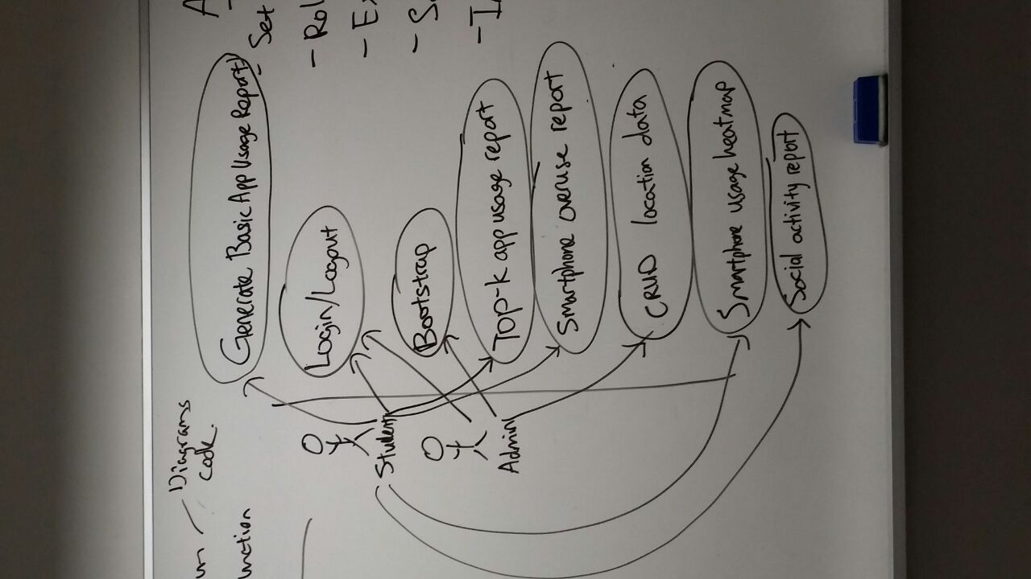

C. LOGICAL DIAGRAM

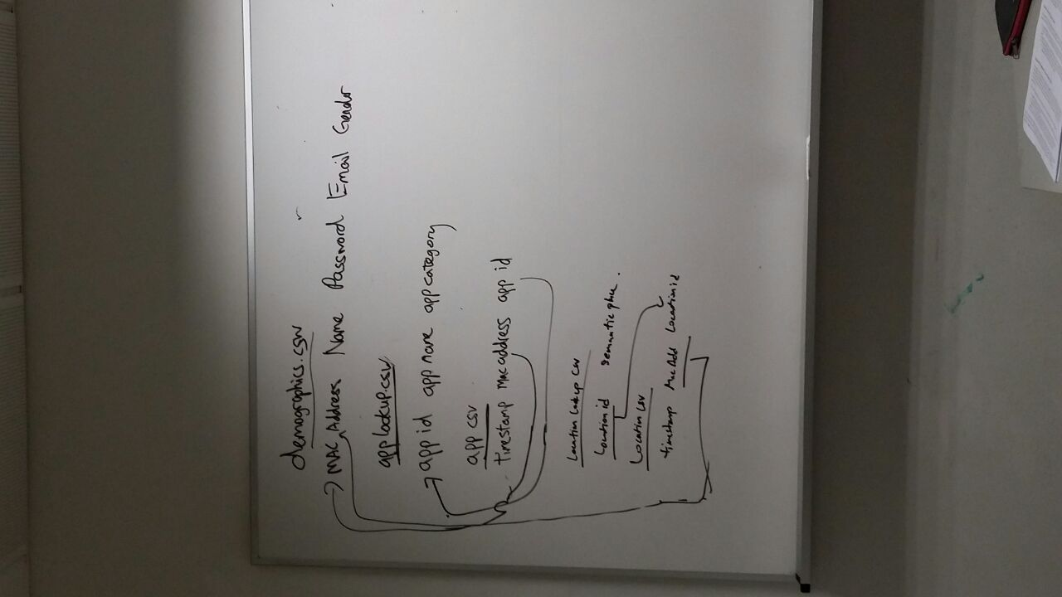

D. DOMAIN DIAGRAM

